FileSync Bugs – 02/20/2012

1. After I deleted a folder and tried to manually go to that URL, it showed me blank table.  
   Very low priority bug. Will fix last.
2. Pre-existing content exception when I create a folder with name as “.”  
   When a user does this in dropbox, they get an err msg “Folders named “.” and “..” are not allowed. I *could* do the same thing, but I don’t think it would be sufficient. In Windows, if you create a folder that starts with a “.”, it pops up an error message “You must type a file name.” And if you try to make a folder called “....”, it just plain old doesn’t do anything. So I should probably disallow folder names from starting with a “.”.  
   Low priority. Will fix close to last.
3. Folder names need to be properly URL escaped when added to the page URL:
   1. Creating a folder with “#” in it’s name, truncates the folder name while browsing to that location and throws an error. I get an error like “The path "/New folder (2)/,.~`!@" in the cabinet "filesync" does not exist and cannot be browsed.”. The actual path is "/New folder (2)/,.~`!@#$%^&amp;()_+-={}[];' ,.
   2. Folder name with single quote breaks javascript.
   3. Having an “&” character in the folder/file name and trying to rename it. I see a “&amp” in the pre-populated text field.
   4. Having a “%” character in the folder name and browsing to that location throws a 400 bad request error.
4. Renaming a file w/o making changes to its original name, increments the copy count. E.g. foo.txt🡪 foo(1).txt. Add in a special exception for when src and dst locations are the same.
5. Under the folder view of the file sync page, files and folder should be sorted alphabetically – folders first.  
   Fixed ☺
6. For modern versions of Firefox, the “more actions” drop down placement issue on folder view page is bad.  
   Fixed (at least in Firefox 3.6... I don’t want to upgrade to a newer version to find out)
7. IE7: “upload files” and “new folder” buttons appear differently.  
   Fixed
8. IE7: None of the buttons seem to work on the folder view page. I see “SCRIPT1028: Expected identifier, string or number [filesync, line 767 character 7](0)” Under the dev. console.  
   Fixed
9. IE 7: Under the flat files view, “Add to File sync” pops up a directory structure. This dialog has GUI issues. Larger than usual and has half the column with background as yellow and half as white.   
   I thought the yellow background was ugly anyway, so I got rid of it. However I can’t easily make the alternating row blue color stretch across 100% of the dialog width. But it looks fine as it is in my opinion, so I’m not going to spend any time on it.  
   As far as the dialog being a different size then usual: I compared the IE7 copy/move dialog to the ones that pop up in the other browsers; it looked exactly the same to me.
10. The file icons based on extension are case-sensitive. So, for example, if you have “foo.jpg” as the filename, the correct icon will be shown, but not for “foo.JPG”.  
    Fixed

Other Bugs I Noticed Tonight

1. Header bar on the “New Folder” pop-up not wide enough (IE7). – also wrong width on “move”, “delete”, etc  
   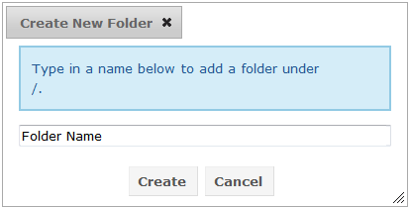  
   Fixed for: “rename”, “move”, “delete”, “copy to”, “New Folder”. Tell me if you find other instances to fix.
2. Cancel button does not work on ANY of the pop-ups “New Folder”, “move”, “delete”, etc. (top-right X icon to close dialog does)  
   Fixed this everywhere. Let me know if you find any exceptions.

# Continued Bug List – 02/21/2012

1. Plupload dialog- after files have uploaded and I click on the tiny grey tick mark next to the uploaded file, the file is removed from the upload list but after closing the dialog, I still see the file I deleted on the file sync page.  
   Won’t fix now; maybe later.
2. All versions of IE and Firefox ONLY: Sand clock/spinning icon does not show up when page is loading (for all actions on file sync page like move, copy, upload files etc.)  
   I can do this, but not quickly. Will fix eventually.
3. Move and Copy dialogs: the “move/copy to selected folder” and “cancel” buttons overlap the directory structure if the tree has more depth (as a result of testing , I managed to create many files and sub folders). You can check it out on .129 ([qatest@lutsendata.com](mailto:qatest@lutsendata.com) 123abc)  
   Bummer. I’ll look into it, but it’s somewhat low priority.

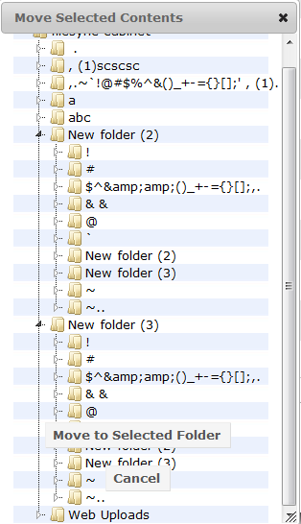

1. The “delete” option on the flat view page does not ask for user confirmation.  
   That would be nice – I’ll change it.
2. Move/copy dialogs: Should show sand clock/ spinning icon when directory structure loading (taking around 3 seconds to do this, given the huge directory structure I have currently).

This used to be happening. Not sure why it broke, but I’ll look into it.

1. Move/copy dialogs: If I click on “move to selected folder” before the directory structure loads (happened to do that accidentally), I get an error message and the head bar shrinks.

I’ll look into this.

1. I tried copying 4 files and 3 folders from location/abc to / and got a gateway timeout. You think we should limit the number of items that can be selected for this operation?

I thought you had a limit of 5 items coded in earlier for move, copy and delete actions. Don’t see that now.  
Jay is writing better-performing code for these actions. We can retest speed once he is done. The limit was increased from 5 items to 15 items.